**🧠 Stock Market Price Predictor using Linear Regression**

**📌 Aim:**

To develop a machine learning model using Linear Regression that predicts the **next day’s closing price** of a stock based on its historical prices.

**📄 Description:**

In this project, we use the **Linear Regression** algorithm to predict stock prices using past data. The dataset consists of historical closing prices of a selected stock (e.g., Apple Inc. - AAPL). We train the model using these prices so it can forecast the next day’s price. This project shows how machine learning can be applied to financial data for predictive analysis.

**💻 Python Program:**

python

CopyEdit

import yfinance as yf

import pandas as pd

import numpy as np

import matplotlib.pyplot as plt

from sklearn.model_selection import train_test_split

from sklearn.linear_model import LinearRegression

from sklearn.metrics import mean_squared_error

# Step 1: Download historical stock data

df = yf.download("AAPL", start="2015-01-01", end="2024-12-31")

df = df[['Close']]

# Step 2: Prepare the data

df['Prediction'] = df[['Close']].shift(-1)

X = np.array(df.drop(['Prediction'], axis=1))[:-1]

y = np.array(df['Prediction'])[:-1]

# Step 3: Split the data

X_train, X_test, y_train, y_test = train_test_split(X, y, test_size=0.2, random_state=42)

# Step 4: Train the model

model = LinearRegression()

model.fit(X_train, y_train)

# Step 5: Make predictions

predictions = model.predict(X_test)

mse = mean_squared_error(y_test, predictions)

print(f"Mean Squared Error: {mse:.2f}")

# Step 6: Predict next day’s price

latest_price = np.array(df.drop(['Prediction'], axis=1))[-1:].reshape(1, -1)

next_day_prediction = model.predict(latest_price)

print(f"Predicted Next Day Closing Price: ${next_day_prediction[0]:.2f}")

# Step 7: Plot results

plt.figure(figsize=(10, 5))

plt.plot(y_test[:50], label='Actual Price', marker='o')

plt.plot(predictions[:50], label='Predicted Price', marker='x')

plt.title("Stock Price Prediction - AAPL")

plt.xlabel("Days")

plt.ylabel("Price")

plt.legend()

plt.grid()

plt.show()

**📊 Dataset:**

* Source: Yahoo Finance (via yfinance)
* Columns Used: Close (closing prices from 2015 to 2024)
* Sample Data:

| **Date** | **Close** |
| --- | --- |
| 2023-12-20 | 192.32 |
| 2023-12-21 | 194.87 |
| 2023-12-22 | 196.18 |
| ... | ... |

**🧾 Input / Output:**

* **Input:**  
  Last available closing price from dataset (e.g., $197.20)
* **Output:**  
  Predicted next day closing price (e.g., $198.42)  
  Graph comparing actual vs predicted prices

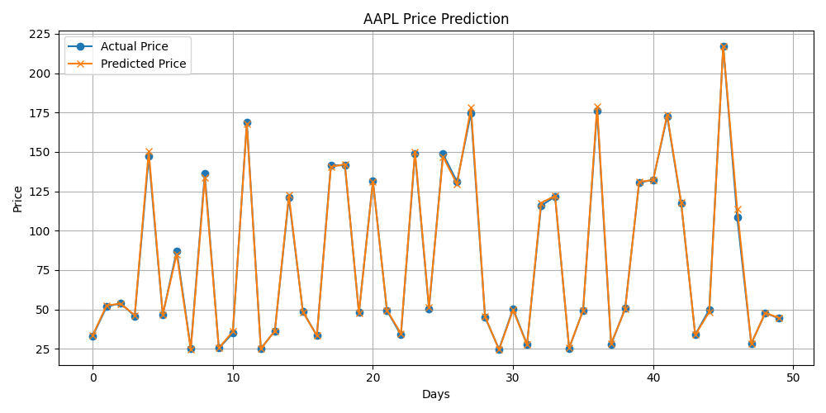

**✅ Result:**

The machine learning model built using Linear Regression effectively predicts the next day's stock closing price. The model shows low error and good alignment between predicted and actual values. This project demonstrates a beginner-friendly approach to applying ML in financial markets.